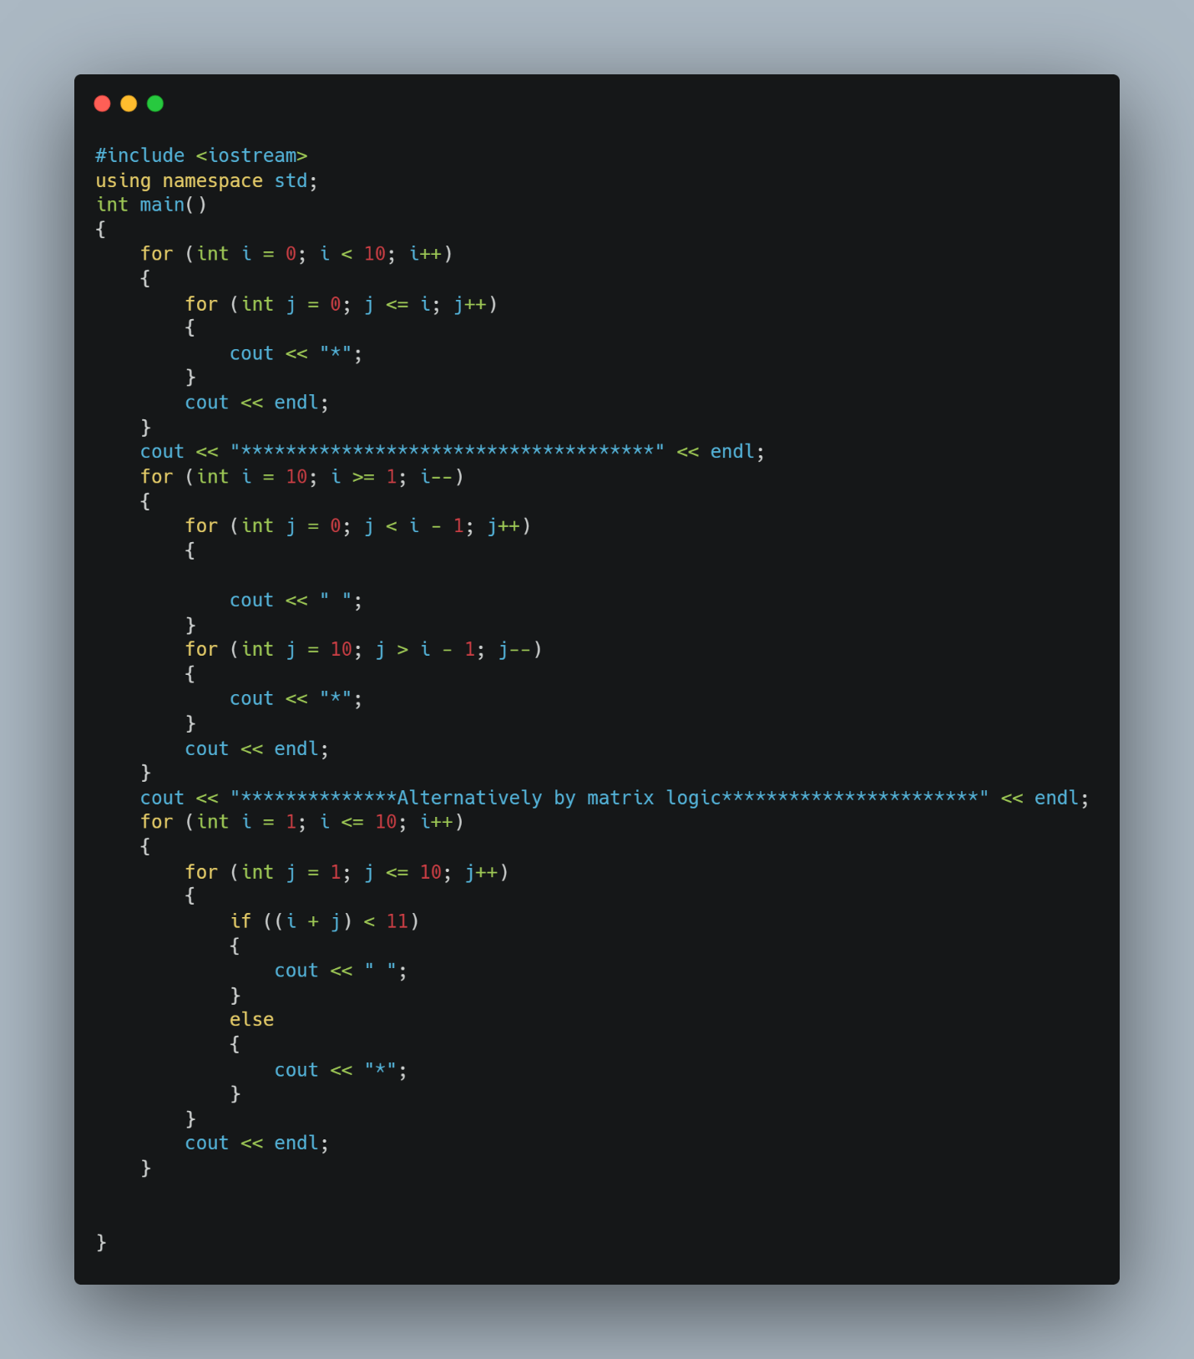**Day 1:**

Hello everyone, It’s me Krishala Khatiwada. I am taking part in ’30-days challenge’, an event organized by ITSNP aiming to encourage females on IT field. I will be exceling in C++ in this time interval of 30 days. #30dayschallenge #Day1ofClg_askmitra

**Day 1:**

I am beginning my learning process from **‘Pattern Printing Programs’** using loop.

**Things I learned today:**

-Wrote pattern printing programs using for loop and while loop.

- left triangle

- right triangle

**Acknowledging following links:**

<https://www.javatpoint.com/cpp-tutorial>

<https://www.programiz.com/cpp-programming/for-loop>

<https://www.w3schools.com/cpp/cpp_while_loop.asp>

<https://www.w3schools.com/cpp/cpp_for_loop.asp>

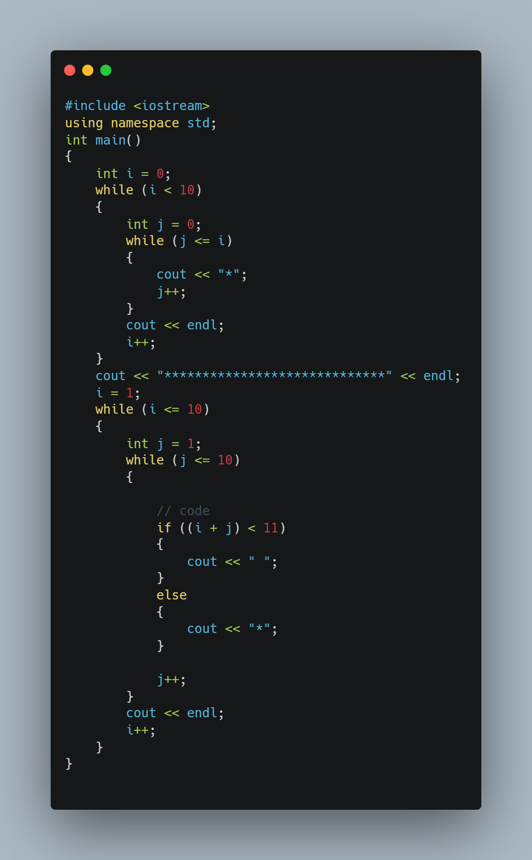

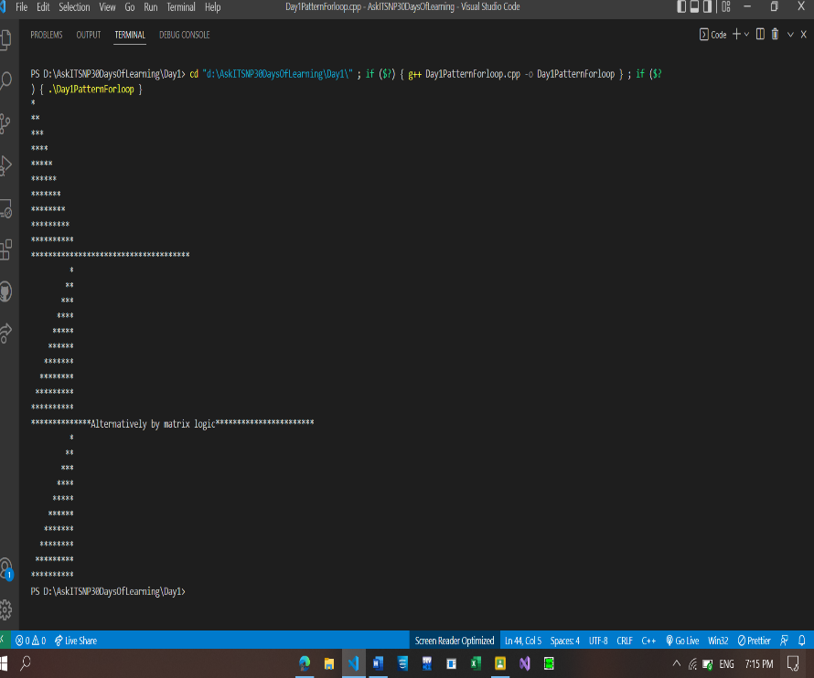

**Day 2:**

**#Day2ofClg_askmitra**

Good afternoon, continuing ’30-days challenge’ with program related to arrays and loop in C++.

**Things I reviewed today:**

**-** Quick Quiz (C++)

-Looping through arrays

-Reversing elements:

* step1: take a number.
* step2: make a temp variable and set it to 0.
* step3: run the while loop until the number you took is not zero.
* step4: extract the reminder and
* step5: use the formula reverse = reverse * 10 + remainder
* step5: remove the last bit of number (num/10)
* step6: number stored in reverse at the end is your result

# Acknowledging following links:

<https://www.w3schools.com/cpp/cpp_quiz.asp>

<https://www.w3schools.com/cpp/cpp_arrays.asp>

<https://www.tutorialspoint.com>

<https://algorithms.tutorialhorizon.com/top-40-problems-on-arrays/>

**Day3:**

[**#Day3ofClg_askmitra**](https://www.facebook.com/hashtag/day1ofclg_askmitra?__eep__=6&__gid__=782203342561098&__cft__%5b0%5d=AZV7cDsp2I8Pra28Fvs23s39ttr9BVvv0yKKWG1CoRezshhuTohT3BSK-mQI9n7Zglo4bWJgk9N-n51aE_qfwAjukVyz9axH85WxRpwcgY4CGp4TokXWjDBSGUlrdyn_3RMolMkI2U65gRHuT8bDyuETAZpsiM22Y0dodALN_uSgQcfeKtTjuOFmRGOlXWJIXZE&__tn__=-UK-R)

Today I am keeping my learning very simple because of my exams.

**Thing I did today:**

* **Displaying Fibonacci Series.**

**Acknowledging following links:**

[**https://www.programiz.com/cpp-programming/examples/fibonacci-series**](https://www.programiz.com/cpp-programming/examples/fibonacci-series)

**PS:** I will be doing same program but with different with different logic like : by implementing while loop, recursions etc. in upcoming days.